**Figures**

**Figure 1.** Map of sampling locations around the Korean peninsula.

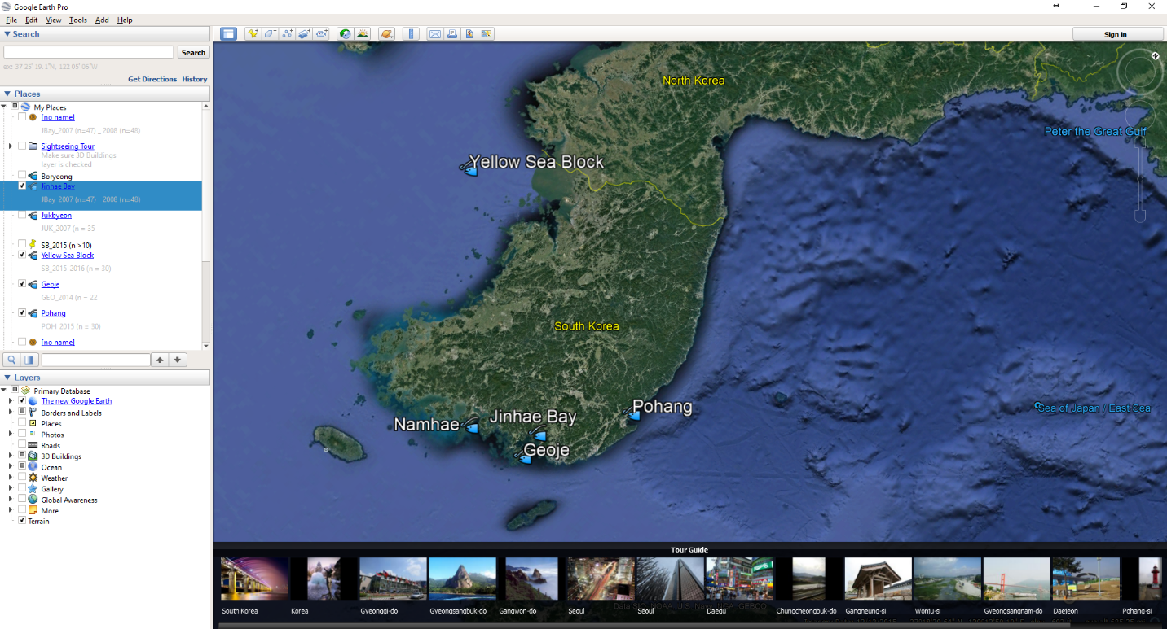

**Figure 2.** Illustration of LA-ICPMS scan line on Pacific cod otolith. Tick marks delineate winter months during each year of life, used to age the individual.

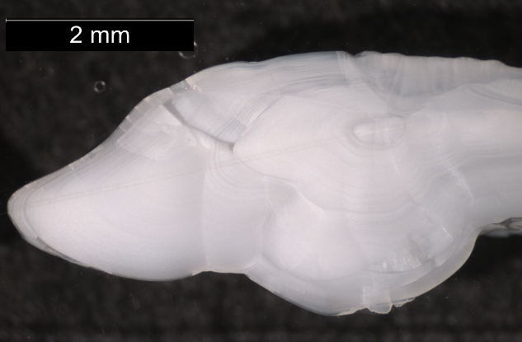

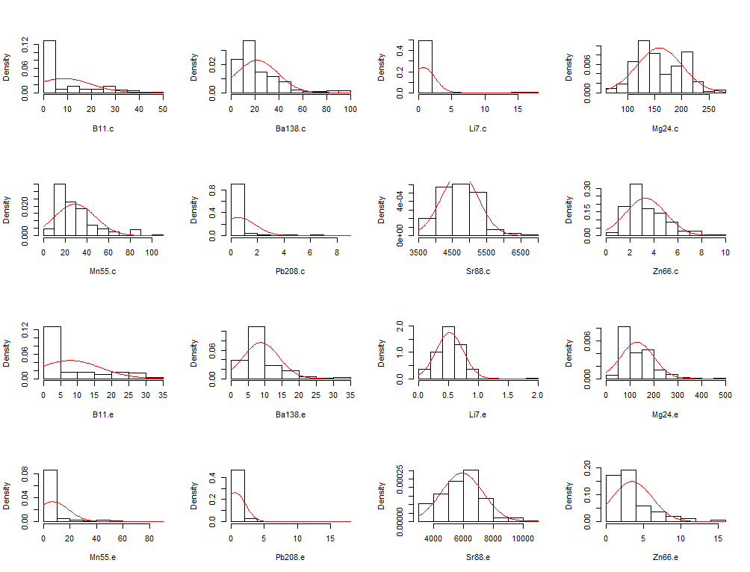**Figure 3.** Histograms of element concentration distributions, before relativization. Element concentrations were split by location on otolith (core, “.c” and edge, “.e”). Note non-normal distributions and differing range of x axis values across elements.

**Figure 4.**

**Figure 5.** Non-metric Multidimensional Scaling ordination of all samples using edge microchemistry. Ellipses show standard deviation around the centroid of each cluster. Vectors display correlation between specific element loadings and ordination axes. Elements are: boron (B11), barium (Ba138), strontium (Sr88), magnesium (Mg24), manganese (Mn55), zinc (Zn66), lithium (Li7) and lead (Pb208). Inset displays Shepard Plot to evaluate fit of NMDS to data.

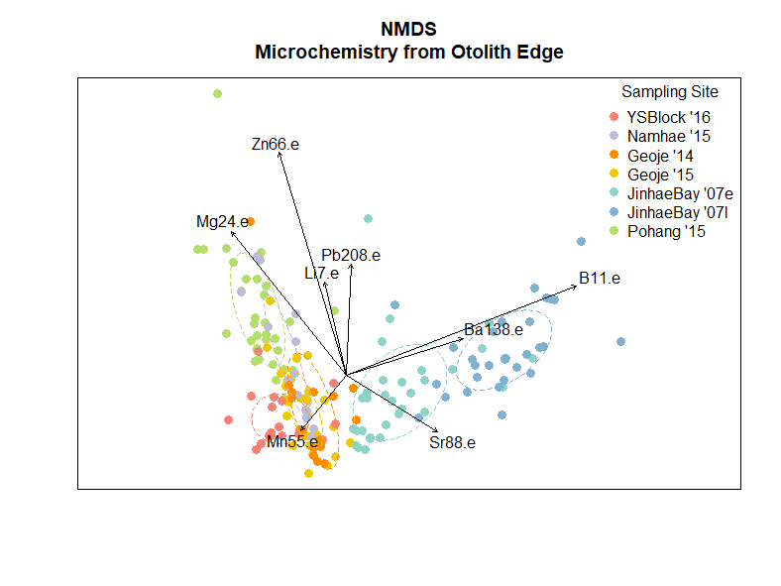

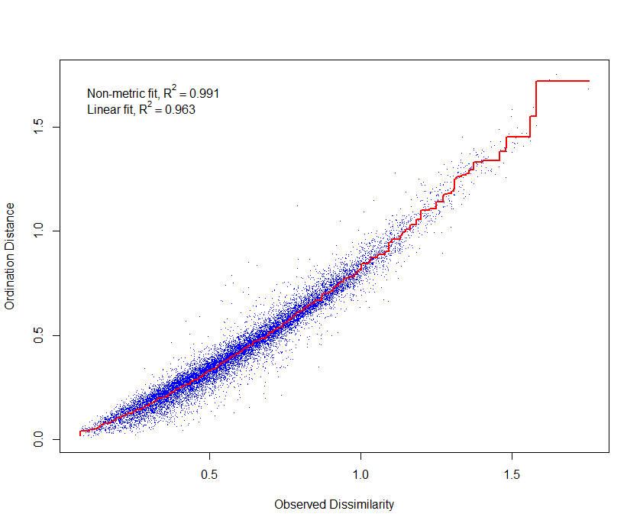

**Figure 6.** Dendrograms of individuals by sampling site, using the Ward method for cluster analysis. Cluster analysis was completed separately using **(a)** otolith core microchemistry, and **(b)** otolith edge microchemistry.

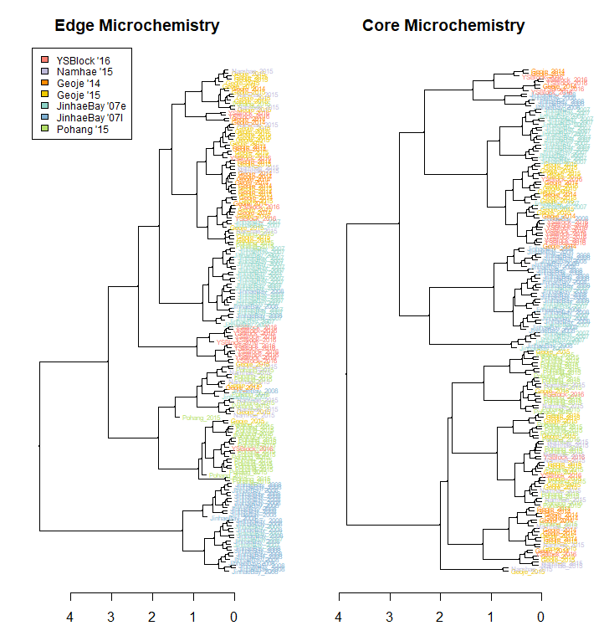

**(b)**

**(a)**

**A close up of a logo

Description generated with very high confidenceA close up of a logo

Description generated with high confidence****Figure 7.** Tanglegram comparing cluster analyses of samples using otolith edge and core microchemistry. Highlighted internal lines show (a) Yellow Sea samples, (b) Pohang samples, (c) Jinhae Bay samples, and (d) Geoje samples.

**(d)**

**(c)**

**(b)**

**(a)**

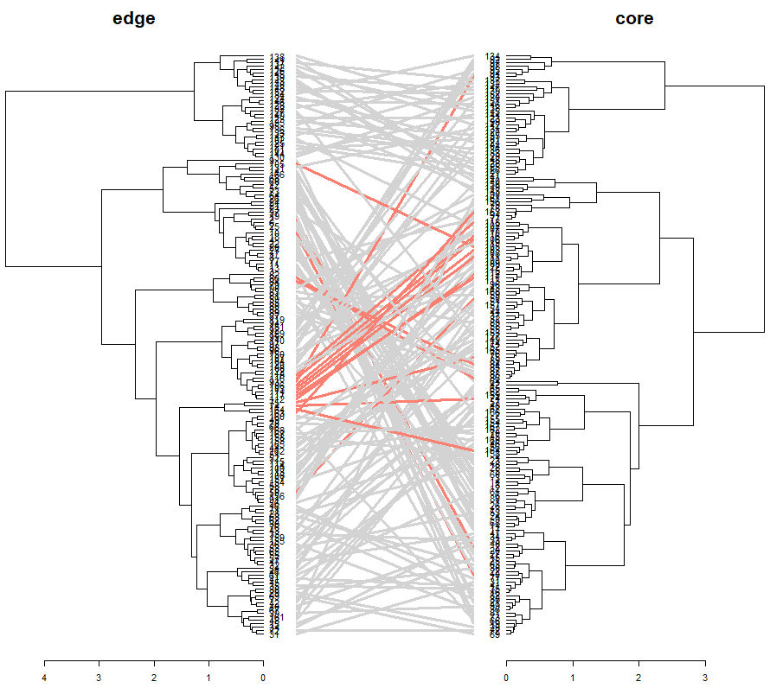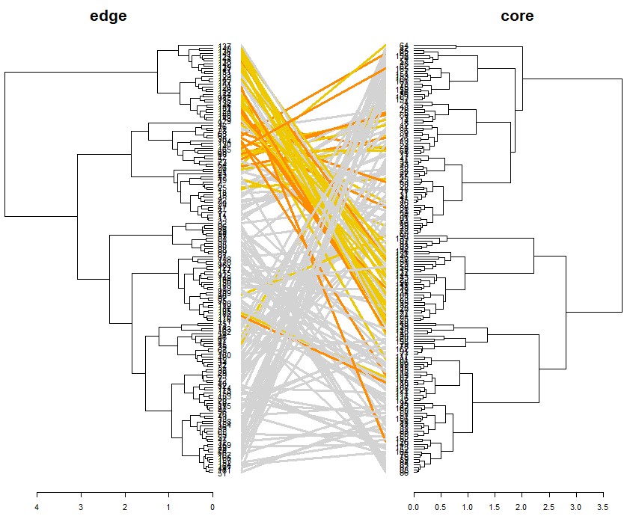

**Figure 8.** Non-metric Multidimensional Scaling ordination of all samples using otolith edge microchemistry, overlaid with groupings from hierarchical cluster analysis on **(a)** edge microchemistry, and **(b)** core microchemistry.

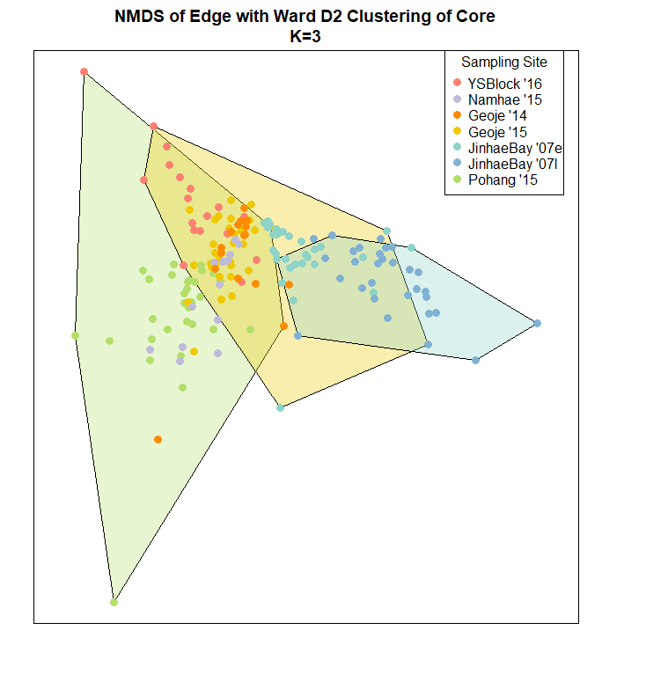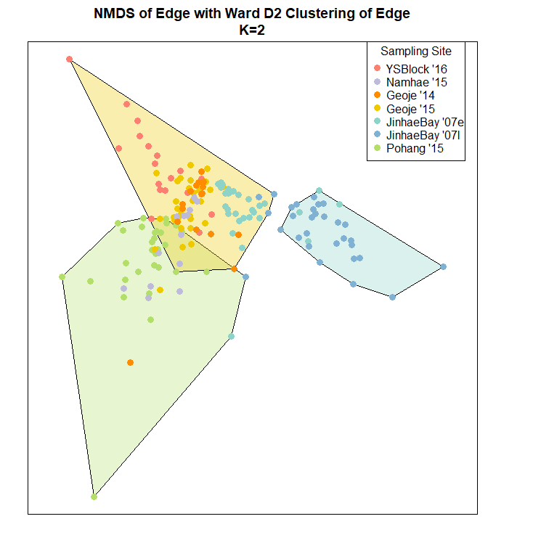

**(b)**

**(a)**

**Figure 9.** Non-metric Multidimensional Scaling ordination of all samples using otolith core microchemistry, overlaid with groupings from genetic assignment tests. Point color indicates sampling site; point shape indicates whether sample was assigned to the genetically distinct west or south/southeast populations.

A screenshot of a cell phone

Description generated with high confidence